

School of Computer Science

Data Visualization

SPEC9995

Maksymilian Drzezdzon

C15311966

Degree: TU060/2

Module Coordinator: Emma Murphy

Declaration of Ownership: I declare that the attached work is entirely my own and that all sources have been acknowledged: 🗹  
**Date: 2021/12/05**

Data Visualisation Assignment 2

**Name**: Maks Drzezdzon

**ID**: C15311966

**Class Code**: TU060/2

**Mode of study**: Part-time

**Dataset**: https://www.kaggle.com/kimjihoo/coronavirusdataset

# Introduction

The target audience are policy makers in said country looking to slow down and see where and how covid is being spread. Given more time I would have wanted to use data from a few countries and compare them.

# Problem – Audience – data

Problem

The target audience are policy makers in said country looking to slow down and see where and how covid is being spread. Given more time I would have wanted to use data from a few countries and compare them.

Audience/User Story

How is covid spreading in South Korea

Data

List here

# Visualisations & Previous iterations

Goals

1. Identify most affected regions (Daegu, Seoul, Gyeonggi-di, Gyeongsangbuk-do)

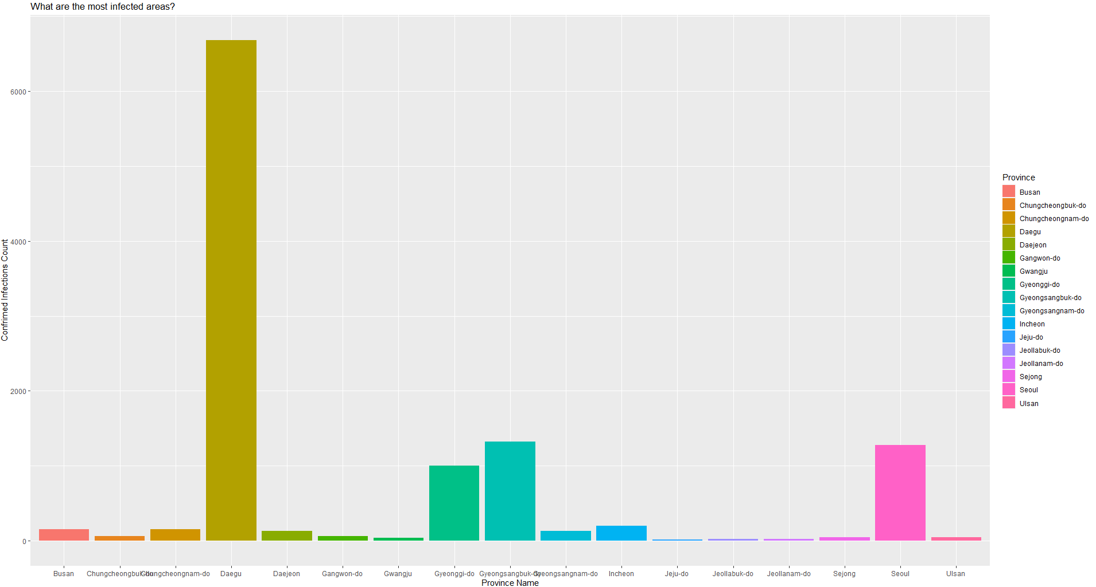

* This was then used to create the first visualisation for this assignment below
* Other areas have little data or too many missing values to work with, hence the top 3-4 were chosen
* This is also an issue that the dataset doesn’t allow much cross checking/linking of columns/fields to other datasets

1st visualisation for assignment

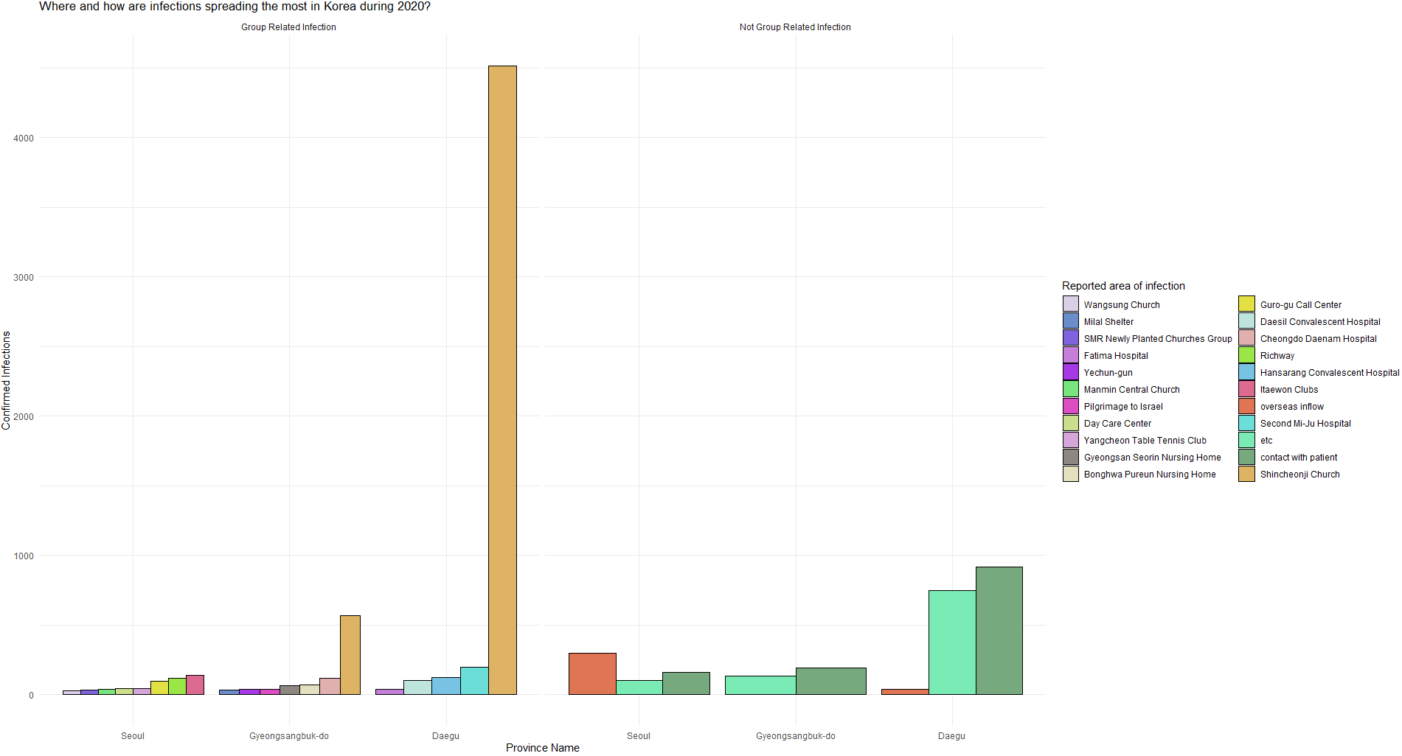

The goal here was to identify how the virus is spreading its biggest cities and segregate them by group vs non-group infection – this was achieved by replacing Boolean values with the titles above. It is not clear what ‘etc’ is. Something that immediately stands out here is that infections from a church in Daegu vastly overtake any other area combine. Limiting capacity if outright closure isn’t possible would be an obvious recommendation. Leaning over to the non-group infections contact with patient seems to be the top mode of infection along with ‘etc’ ending with plane travel in Seoul which seems to be the least impacted province from the top 4 most infected, at least when compared to the other 2.

1. Drill down into age groups and temperatures (there isn’t a way to map age groups back to specific regions unfortunate, hence a general overview of the country is used)

* The first iteration didn’t work out so well where I tried to map both weather records with cases per age group

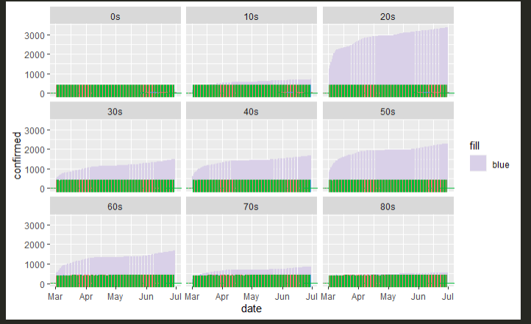

After reviewing the data, I tried doing the same thing but rather for the 4 selected regions, this was then layered on top of the original graph where the temperature values were upscaled by 100 when compared to the infections. Some other early work was to use a library called patchwork that combines graphs together however I’m not sure if id loose marks for that because they’re not combined into one visualisation like the one below but rather just on the same pane.

2nd visualisation for assignment

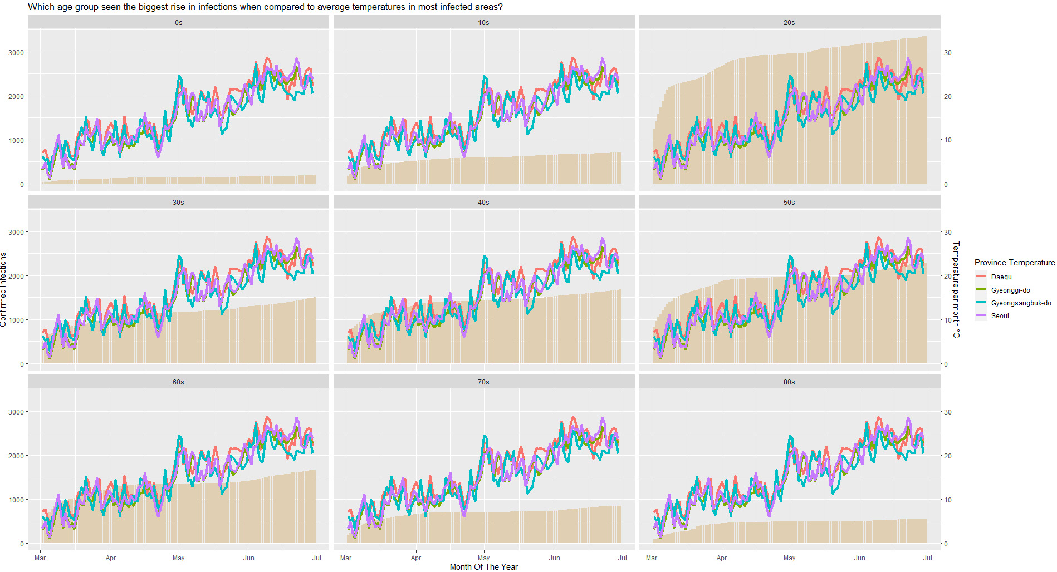

The idea here was to isolate data from each age group and map it back to each province and compare it to weather conditions over the 5/6-month period – this was not entirely possible - instead the overall confirmed case count for the whole country was segregated by age group and combined with a combination of line plots constructed from the accompanying weather dataset. They were then both filtered to have overlapping dates so they would share the x-axis.

The purpose of this was to see which groups were carrying the infection the most but also if weather had any significant role to play as one would imagine. This would potentially unveil how did each age group respond to both information dispensed by their media and current conditions – the point I’m trying to allude to is, did the 20-year-olds have a linear uptick in infections, which they did or did any older groups show a rise and fall despite a variable that would stimulate the spread of the disease, that being weather in this case as it was the only one that offered an ability to be mapped to the other dataset.

Personally, this visualisation could have been better but due to the dataset offering limited features and little space for more engineered approaches. Even though there is a linear relationship between temperatures and covid cases rising across most groups this isn’t the precise insight I was going for – albeit the same formula would be used however in order to properly discern the information a precise separation between age groups and regions would be required and this wasn’t available. I wanted to attempt this regardless to examine the relationship.

Furthermore, a similar analysis would have been conducted if there was a way to map age group infections to regions and compare the amount of early adulthood education facilities which are provided. This idea was scrapped because just as the visualisation above, it wouldn’t have given the desired output due to dataset being limited.

1. Elderly population/Elderly living alone in most affected areas

3rd Visualisation for assignment

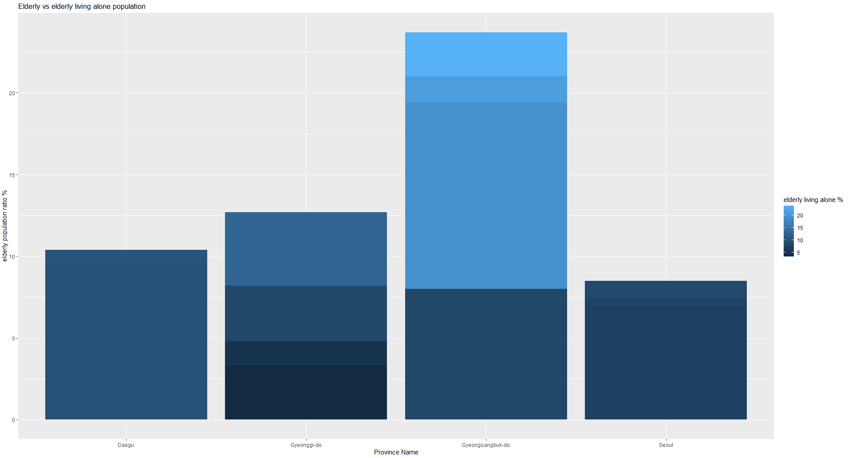

Alternative version

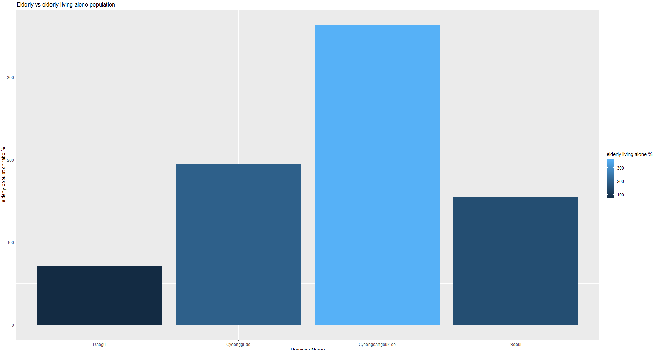

The rational behind this is that one uses a combination of values whereas the other maps the whole province per bar which shows a much better split between the size of chunks/groups of elderly living alone. As mentioned above – there isn’t a way to map data back to a per province basis when looking at more interesting tables. The only one where this was possible to an extent, was the second visualisation because the date could be used as an x axis that could combine and overlay multiple graphs.

# Code

# Data setup

case_df = read.csv("/Users/Grim/Documents/GitHub/covid19/Case.csv", sep= ',' , header=T )

# subset(df_here, select = -c(cols_to_remove))

# pre-setup

# changing color palette setup

n_color = 22

set.seed(2643598)

palette = distinctColorPalette(n_color)

# test palette

# http://www.sthda.com/english/wiki/ggplot2-colors-how-to-change-colors-automatically-and-manually

# scale_fill_manual() for box plot, bar plot, violin plot, etc

# scale_color_manual() for lines and points

pie(rep(1, n_color),

col=palette,

radius=1,

main="test palette")

# data prep

# find most infected areas

colnames(case_df)

most_infected_areas = subset(case_df, select = -c(case_id, latitude, longitude))

most_infected_areas

most_infected_areas_sum = sqldf("select province as Province, sum(confirmed) as 'Confrimed Infections' from most_infected_areas group by province")

most_infected_areas_sum_plot = ggplot(data = most_infected_areas_sum, aes(Province, `Confrimed Infections`, fill=as.factor(Province))) +

geom_col(position="dodge") +

labs(x="Province Name", y="Confrimed Infections Count", title="What are the most infected areas?", fill="Province")

most_infected_areas_sum_plot

# pick out top 4 hot spots

hotspots_df = sqldf("select * from most_infected_areas where province == 'Daegu' or province == 'Seoul' or province == 'Gyeonggi-di' or province == 'Gyeongsangbuk-do'")

hotspots_df = sqldf("select * from hotspots_df where confirmed >= 30")

hotspots_df

colnames(hotspots_df)[4] = "Infected_In_Location"

hotspots_df

# Group vs non group infections

pie(rep(1, n_color),

col=palette,

radius=1,

main="test")

plot_for_assign_requirements_1 = ggplot(data=hotspots_df, aes(x=province, y=confirmed, fill=Infected_In_Location )) +

scale_fill_manual(values = c(palette)) +

geom_bar(stat="identity", color="black", position=position_dodge())+

theme_minimal() +

labs(x="Province Name", y="Confirmed Infections", title="Where are infections spreading the most?", fill="Reported area of infection")

plot_for_assign_requirements_1

weather_df_filtered = sqldf("select * from weather_df where province == 'Daegu' or province == 'Seoul' or province == 'Gyeonggi-di' or province == 'Gyeongsangbuk-do'")

tmp_weather = drop_na(weather_df_filtered)

# filter the dates to match confrimed_cases_age_group_timeline_df

tmp_weather = subset(tmp_weather, date > "2020-03-01")

class(tmp_weather$date)

tmp_weather$date = as.Date(tmp_weather$date, format = "%Y-%m-%d")

tmp_weather

weather_plot_3_hotspots = ggplot() +

geom_line(data=tmp_weather, aes(x=date, y=avg_temp, group=province, colour=province), stat="identity") + labs(x="date", y="avg_temp",

title="which groups spread it the most and does weather have an effect?", fill="province")

confrimed_cases_age_group_timeline_df = read.csv("/Users/Grim/Documents/GitHub/covid19/TimeAge.csv", sep= ',' , header=T )

# whos spreading them?

colnames(confrimed_cases_age_group_timeline_df)[3] = "age_group"

confrimed_cases_age_group_timeline_df$date = as.Date(confrimed_cases_age_group_timeline_df$date, format = "%Y-%m-%d")

plot_for_assign_requirements_2 = ggplot() +

geom_bar(data=confrimed_cases_age_group_timeline_df, aes(x=date, y=confirmed, color="#A4A4A4"), stat="identity", color="black", position=position_dodge())+

facet_wrap(~age_group) +

labs(x="Month of the year", y="Confirmed Infections", title="Which age group got infected the most during the months of March to July?",

fill="")

# patchwork functionality allows to add plots to display them side by side

# however im not sure if id loose marks for this

# library(patchwork)

# plot_for_assign_requirements_2 + weather_plot_3_hotspots

ggplot() +

geom_bar(data=confrimed_cases_age_group_timeline_df, aes(x=date, y=confirmed, fill="blue" ), stat="identity") +

facet_wrap(~age_group) +

scale_fill_manual(values = c(palette)) +

geom_point(data=tmp_weather, aes(x=date, y=avg_temp, group=province, colour=province), position = position_dodge(width = 0.9), shape=3, size=5, show.legend=FALSE)

# now combine iterations to 1 viz

colnames(tmp_weather)[2] = "Province Temperature"

pie(rep(1, n_color),

col=palette,

radius=1,

main="test palette")

ggplot() +

geom_bar(data=confrimed_cases_age_group_timeline_df, aes(x=date, y=confirmed, fill = "blue"), size = 1, stat="identity", position="stack", show.legend=FALSE) +

scale_fill_manual(values = c(palette)) +

facet_wrap(~age_group) +

labs(x="Month Of The Year", y="Confirmed Infections", title="In which age group did infections increase when compared to average temperatures in most infected areas?", fill=" ") +

geom_line(data=tmp_weather, aes(x=date, y=100*avg_temp, group=`Province Temperature`, colour=`Province Temperature`), size=1.5)+

scale_y_continuous(sec.axis = sec_axis(~./100, name = "Temperature per month °C"))

region_df = read.csv("/Users/Grim/Documents/GitHub/covid19/Region.csv", sep= ',' , header=T )

case_df = read.csv("/Users/Grim/Documents/GitHub/covid19/Case.csv", sep= ',' , header=T )

most_infected_areas_sum_plot = ggplot(data = most_infected_areas_sum, aes(Province, `Confrimed Infections`, fill=as.factor(Province))) +

geom_col(position="dodge") +

labs(x="Province Name", y="Confrimed Infections Count", title="What are the most infected areas?", fill="Province")

most_infected_areas_sum_plot

region_df

tmp_df = sqldf("select province, sum(elderly_population_ratio) as elderly_population_ratio, sum(elderly_alone_ratio) as elderly_alone_ratio from region_df where province == 'Daegu' or

province == 'Seoul' or province == 'Gyeonggi-do' or province == 'Gyeongsangbuk-do' group by province")

tmp_df

tmp_df_2 = sqldf("select province, elderly_population_ratio, elderly_alone_ratio from region_df where province == 'Daegu' or

province == 'Seoul' or province == 'Gyeonggi-do' or province == 'Gyeongsangbuk-do'")

tmp_df_2

living_alone_elderly_population = ggplot(data = tmp_df_2, aes(province, elderly_alone_ratio , fill=elderly_alone_ratio)) +

geom_col(position="dodge") +

labs(x="Province Name", y="elderly population ratio %", title="Elderly vs elderly living alone population", fill="elderly living alone %")

living_alone_elderly_population